|  |  |
| --- | --- |
| **ID** | PNT2022TMID02457 |
| **Project TEAM Name** | A Safety Gadget For Child safety monitoring and notification |
| **Team Members** | KISHORE B ,JANASHREE K, KAVIYA G , CHARAN GANDHI |

Create A Database In Cloudant DB

Aim: To create a database in Cloudant DB to store location data.

Steps followed:

● Logged in to IBM Cloud account ● Navigated to `./resource.

# ● Clicked on the “Create Resource +” button ● Searched for “Cloudant”

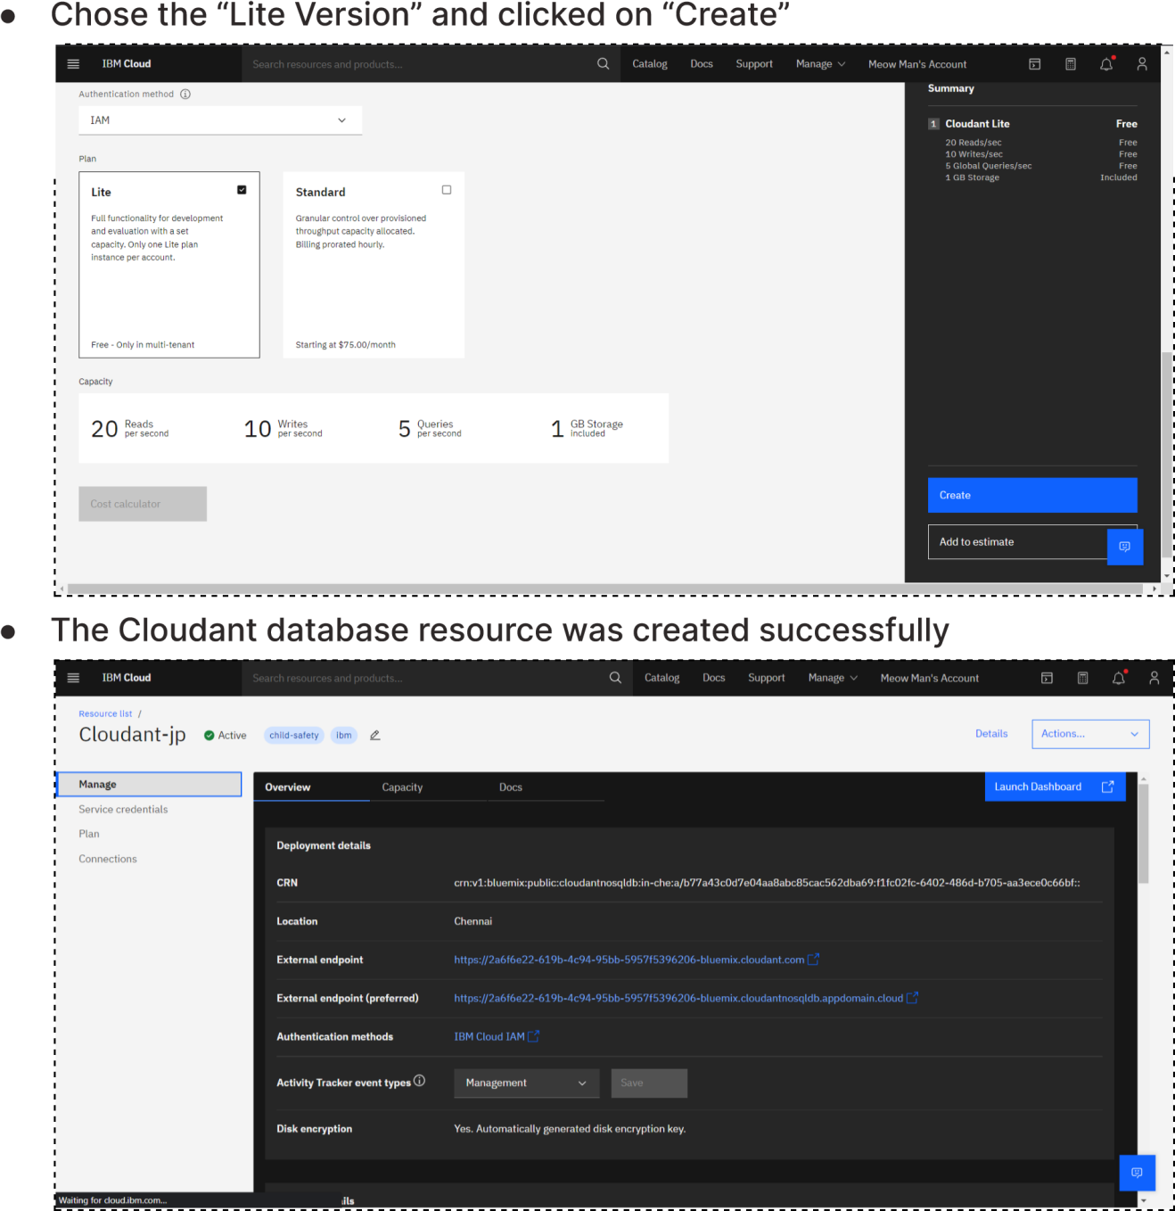

# ● Clicked on the “Create Resource +” button ● Searched for “Cloudant”



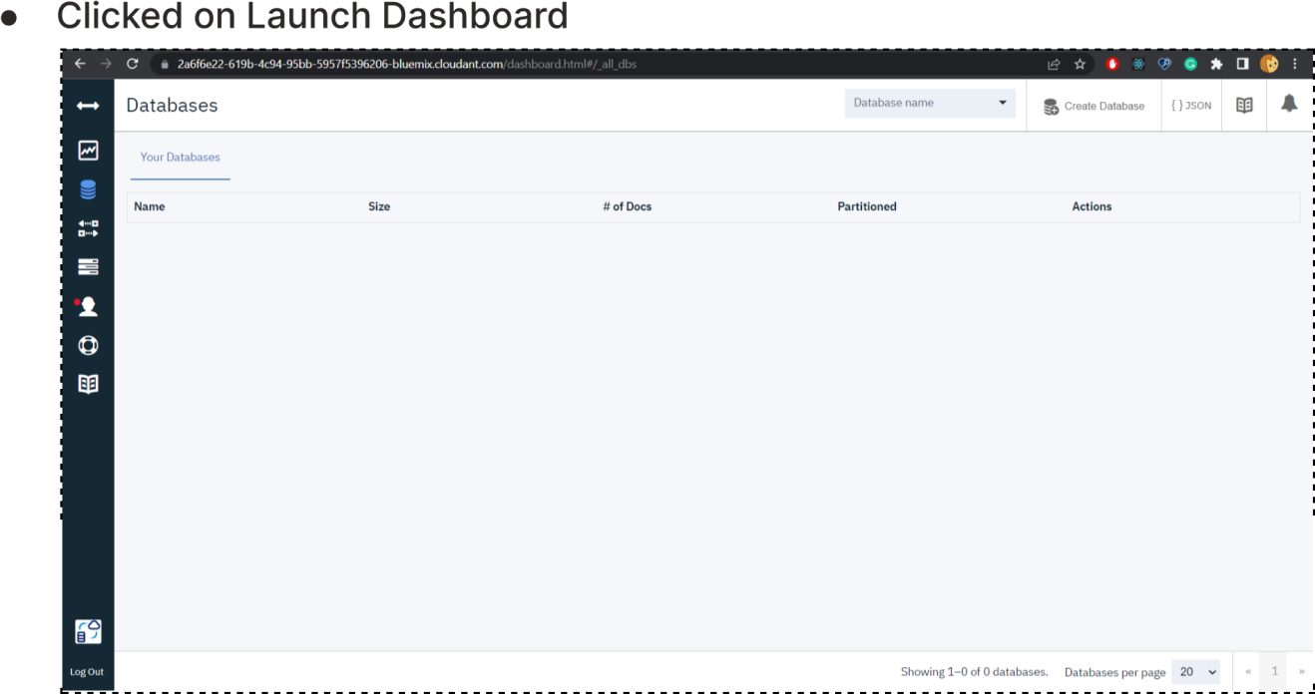

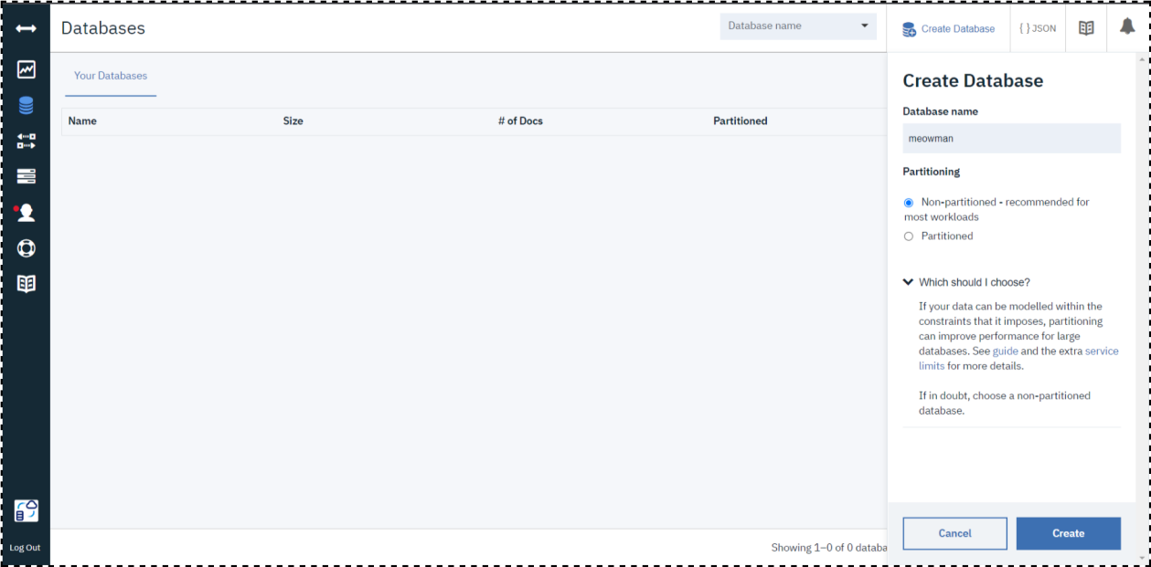● Clicked on “Create Database”. Entered “meowman” as the database name and the “Non-partitioned” option Result:

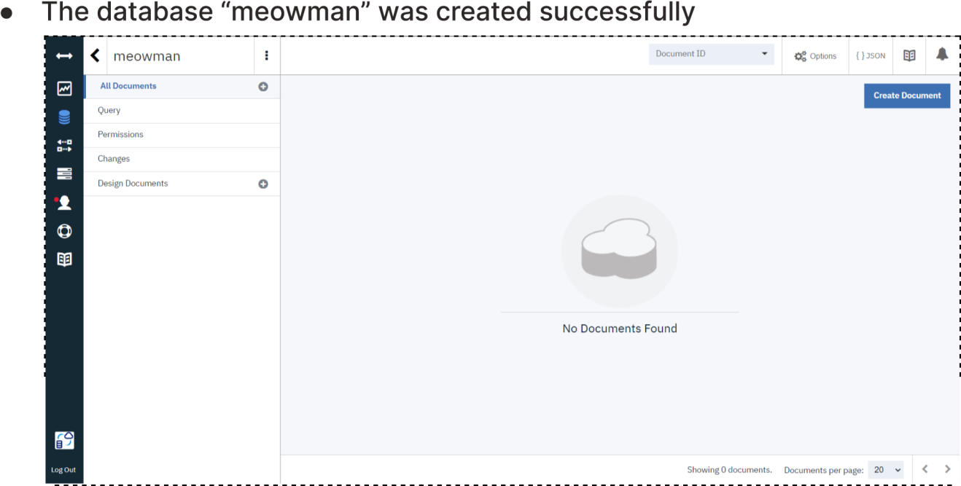

# A database to store the location data was created successfully on Cloudant DB